*USER MANUAL*

INDEX

* Introduction -------------------------------------------------------------------------- Page 3
* Pages
  + Login -------------------------------------------------------------------------- Page 4
  + Register Visitor ------------------------------------------------------------- Page 5
  + Profile Visitor --------------------------------------------------------------- Page 6
  + Town Events ---------------------------------------------------------------- Page 6
  + Places ------------------------------------------------------------------------- Page 7
  + Update Visitor -------------------------------------------------------------- Page 7
  + Update Password ---------------------------------------------------------- Page 8
  + History ------------------------------------------------------------------------ Page 8
  + Site Map ---------------------------------------------------------------------- Page 9
  + About -------------------------------------------------------------------------- Page 9
  + Profile Admin ---------------------------------------------------------------- Page 10
  + Update Place ---------------------------------------------------------------- Page 10
  + New Place -------------------------------------------------------------------- Page 11
  + Update Event ---------------------------------------------------------------- Page 11
  + New Event -------------------------------------------------------------------- Page 12

INTRODUCTION

The objective of this section is to explain the operation of the website "New Codington Portal".  
The website allows a user to register at the website to see and register at events available. The user also can access various public spaces.

Note that this application is compatible with "Internet Explorer", "Mozilla Firefox" and "Google Chrome".

PAGES

* “LOGIN” PAGE

On this page, the user can register in the system even if he has not been done or access to the portal using his username and password.

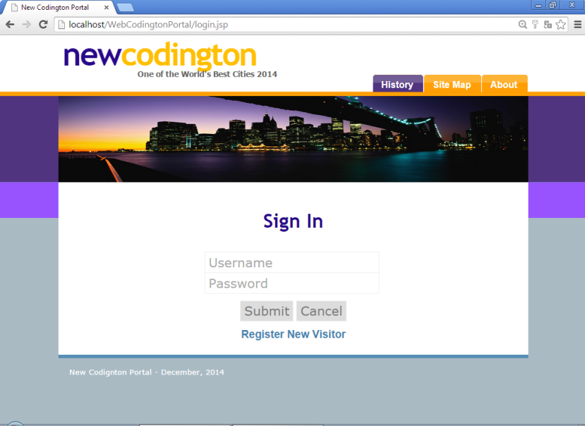

If the username or password is wrong, the page displays the following message.

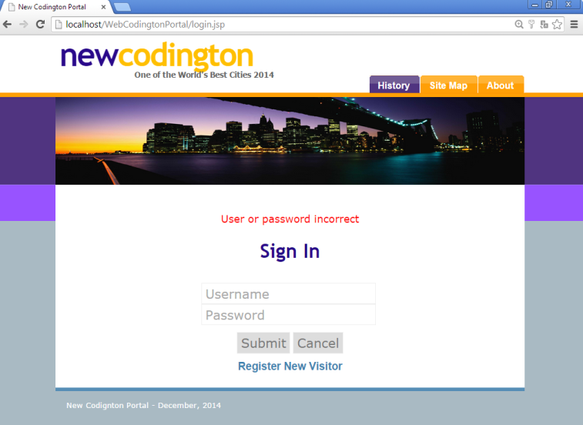

* “REGISTER VISITOR” PAGE

On this page the user can register at the site. For this, the system will request some personal information such as:

* + First Name: Length between 1-30.
  + Last Name: Length between 1-30.
  + Username: Length between 6-12. Must be unique.
  + Password: Length between 6-15.
  + Confirm Password: It must match with password.
  + DNI: Must be a valid DNI and must have the format: XX.XXX.XXX-L
  + Phone Number: It is a numeric data. Length between 10-20
  + Email: Length between 3-200. Must contain @domain.
  + Address: Length between 0-30.

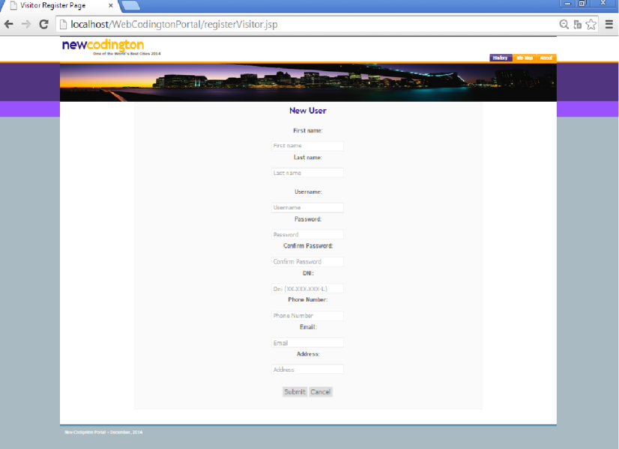

If the password field and Confirm password field are not equal the following message is displayed

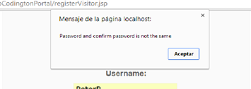

If the DNI is not correct or has an invalid format the following message is displayed

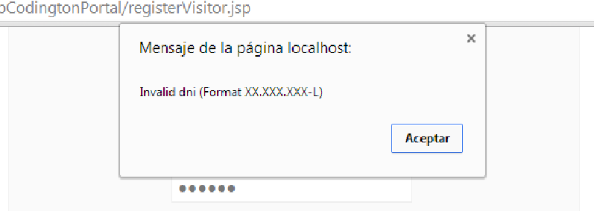

* “PROFILE VISITOR” PAGE

The visitor accesses to this page after entering his username and password. Here he can see his personal information and a list of events that he has registered. In this page, visitors can also search for an event by its partial name.

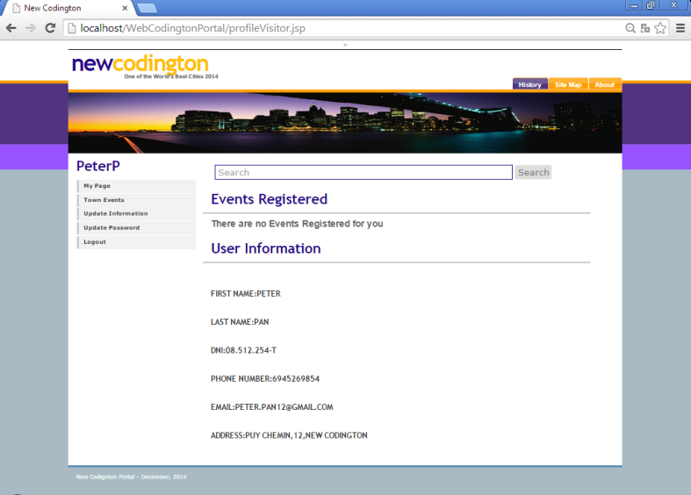

* “TOWN EVENTS” PAGE

Here the visitor can see the different public spaces in each of the areas of the city, north and south. In this page, visitors can also search for an event by its partial name.

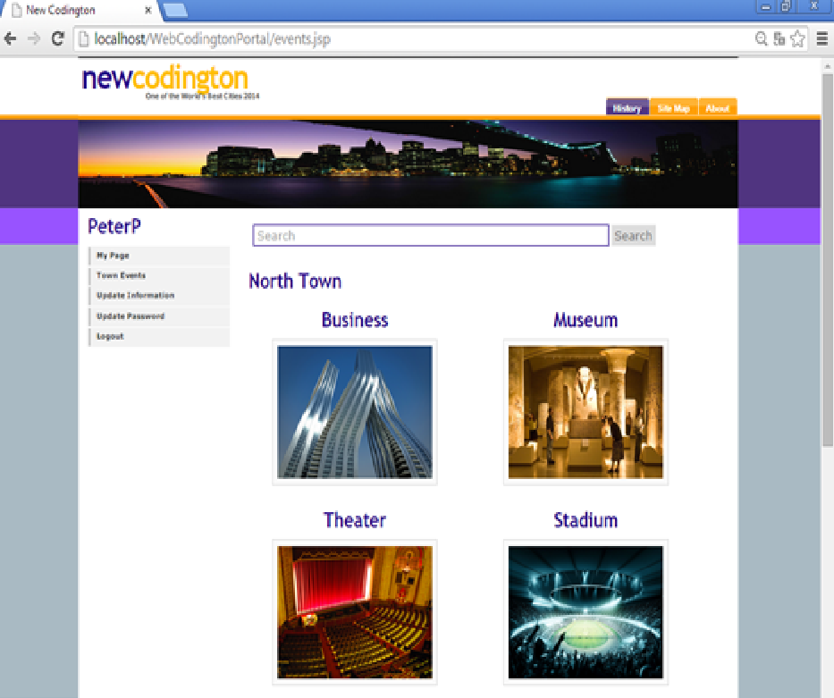

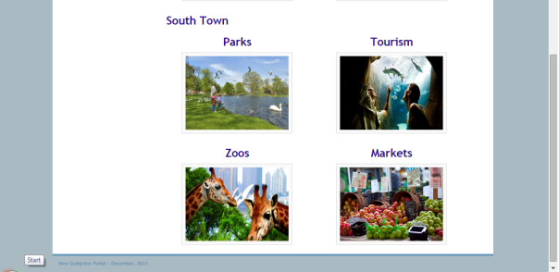

* “PLACES” PAGES

When the visitor selects each of the places pictures, he can see the list of events celebrated in this place.

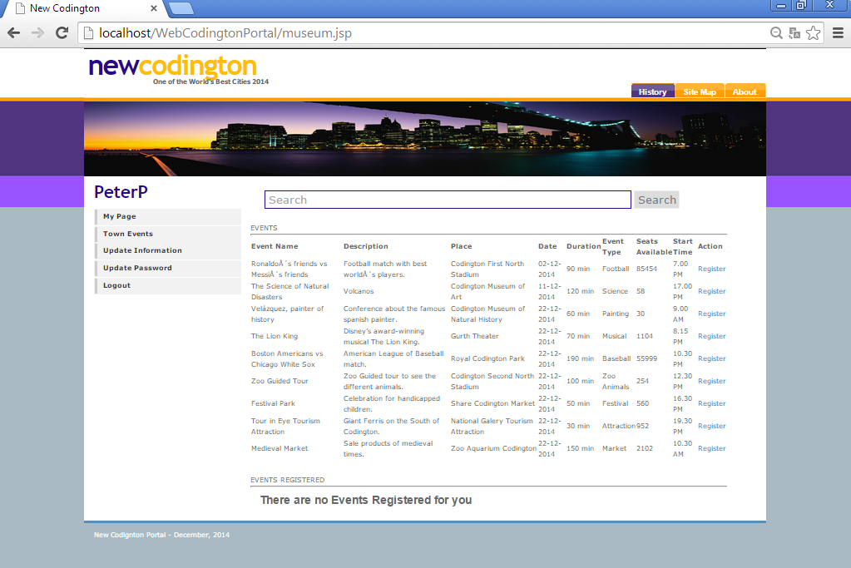

* “UPDATE VISITOR” PAGE

On this page visitors can edit their personal information.

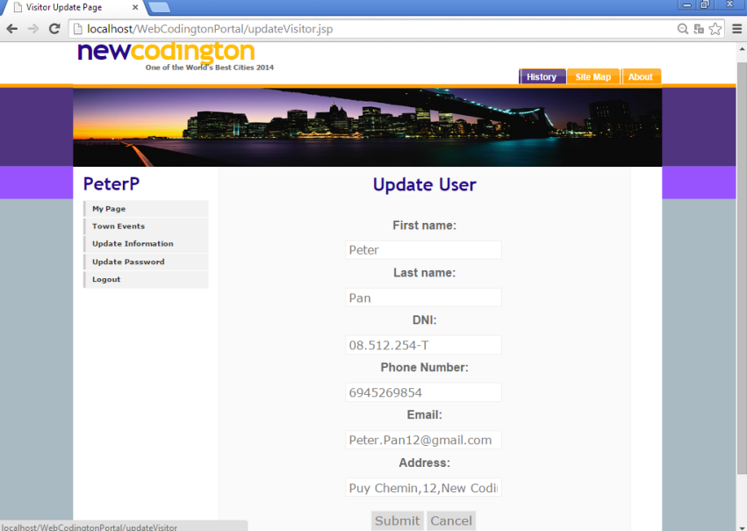

* “UPDATE PASSWORD” PAGE

On this page visitor can update his password.

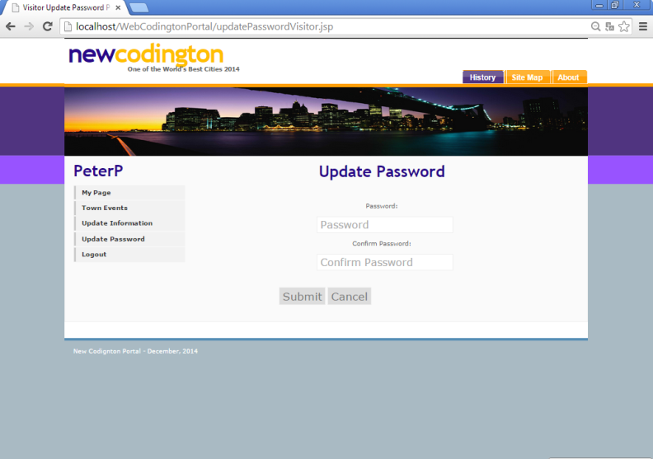

* “HISTORY” PAGE

On this page, we can see the history of the city.

* “SITE MAP” PAGE

This page is the site map. The administrator can access each page of the web directly from here. Visitors can access all page which do not have administrator privilege.

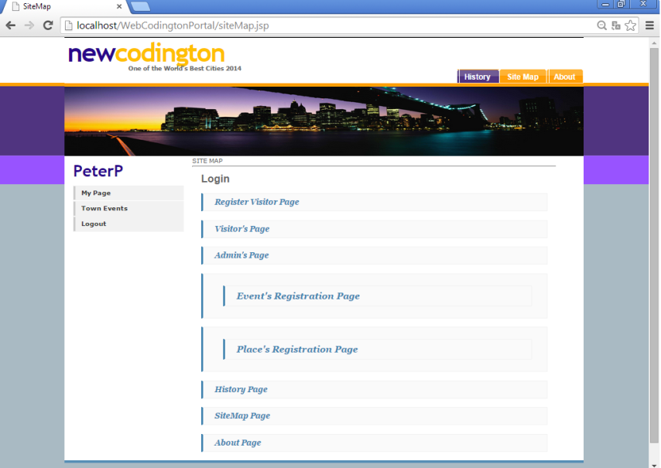

* “ABOUT” PAGE
* “PROFILE ADMIN” PAGE

On this page administrator can view and delete events and places existing. He can accesses to update Event and update Place pages.

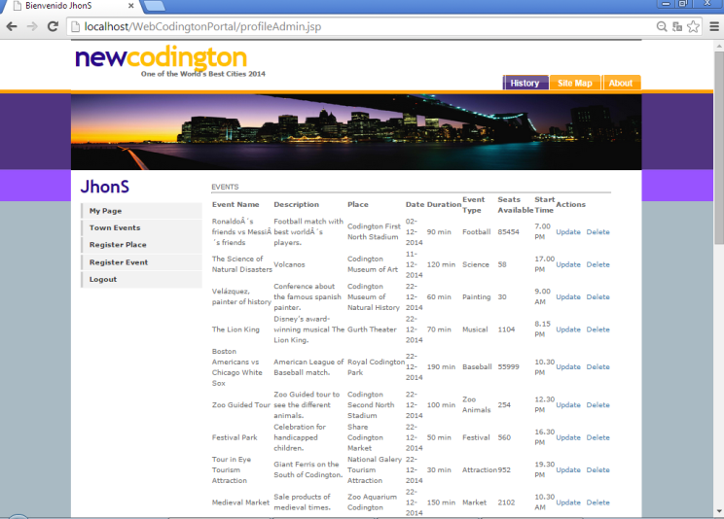

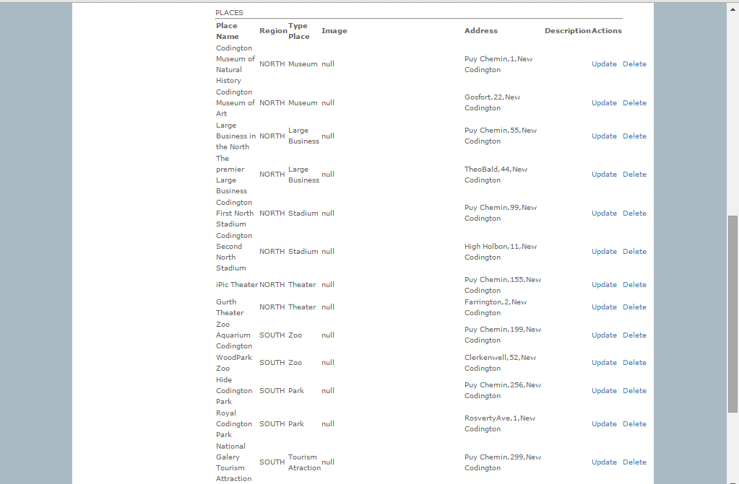

* “UPDATE PLACE” PAGE

On this page the administrator can edit any place existing.

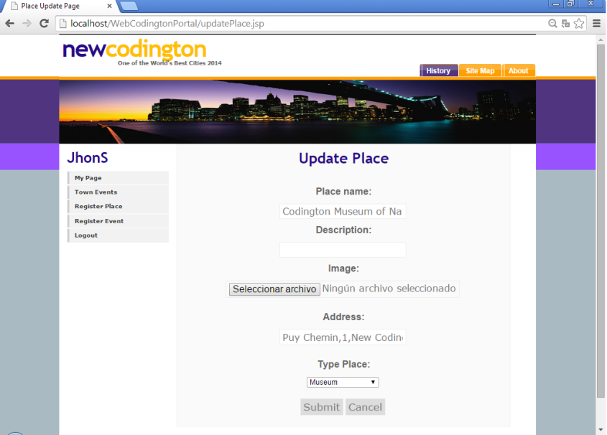

* “NEW PLACE” PAGE

Here the administrator can add new places.

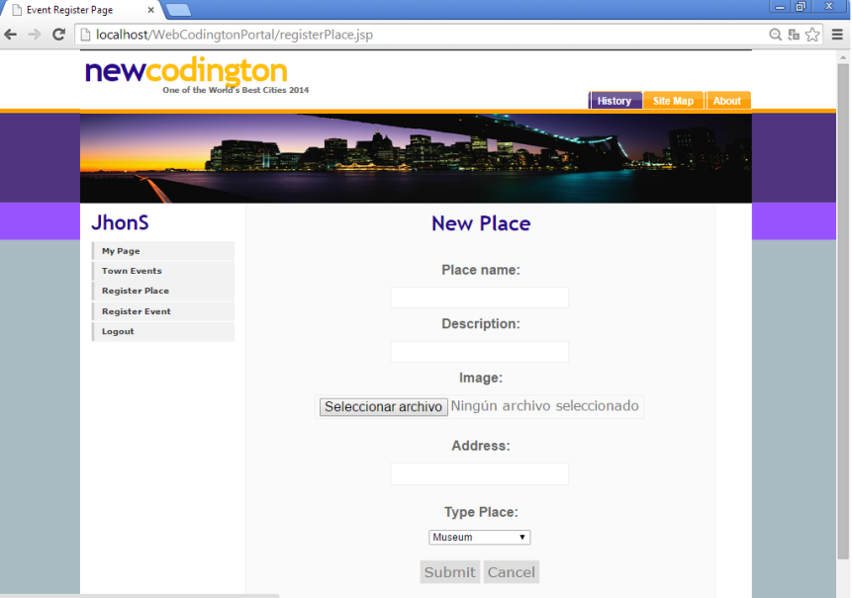

* “UPDATE EVENT” PAGE

On this page the administrator can modify existing events

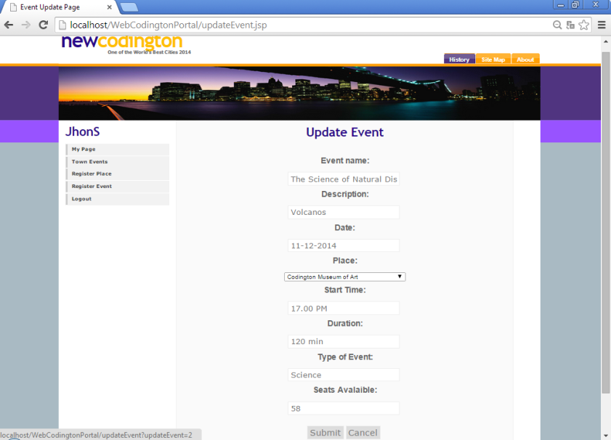

* “NEW EVENT” PAGE:

Here the administrator can add new events.

